Question 1 Product Order Calculator
Part 1 Display available products
JavaScript code
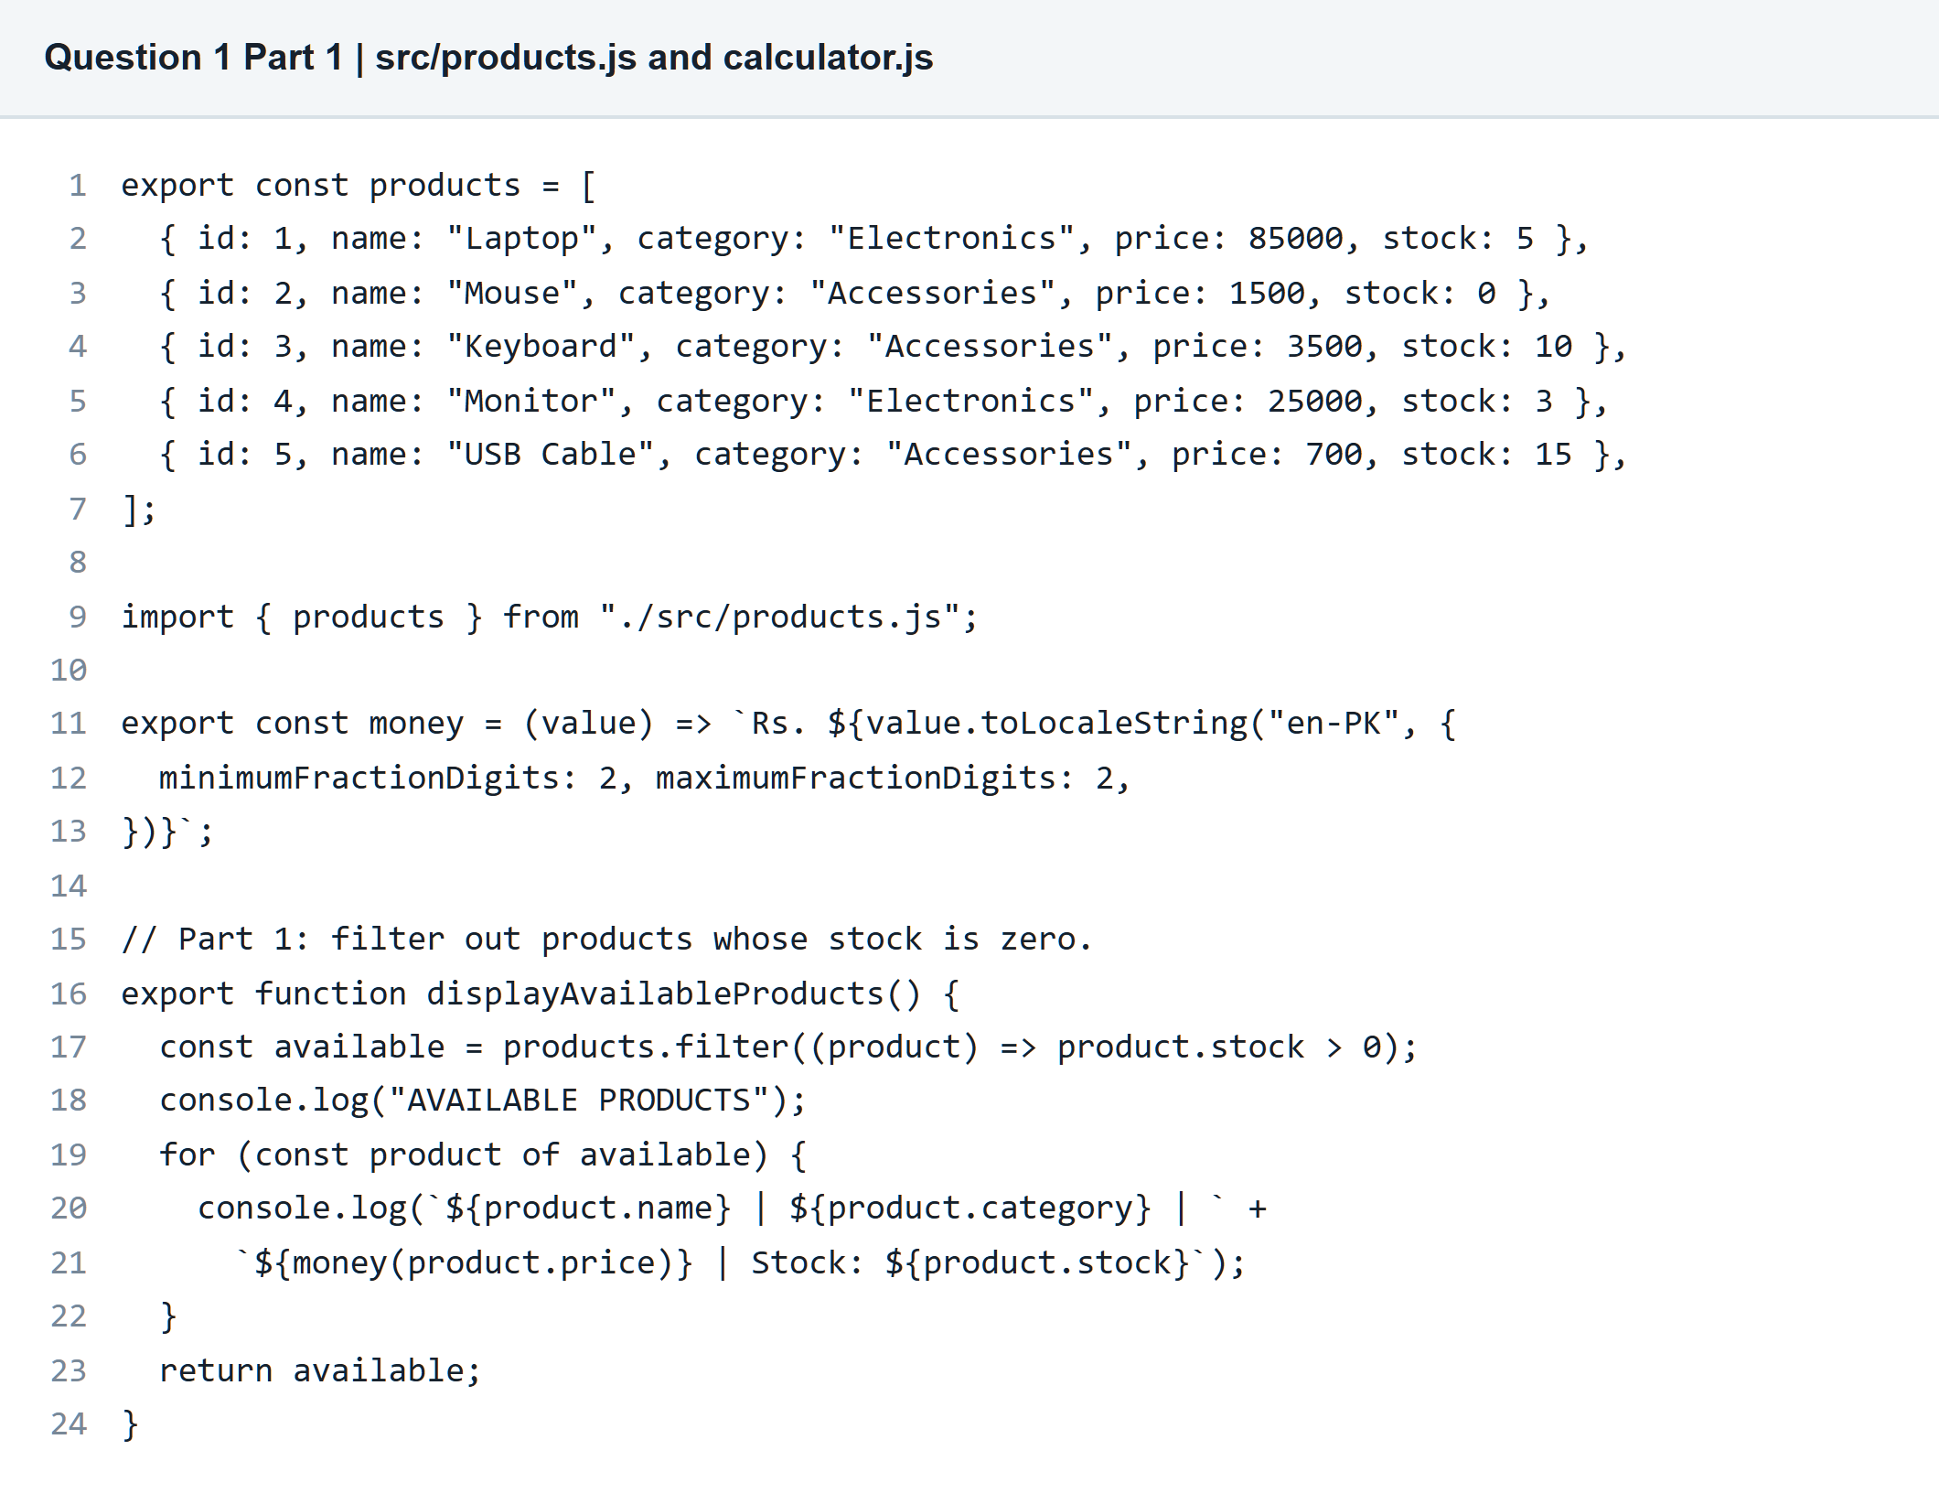

Question 1 Product Order Calculator
Part 2 Calculate order totals
JavaScript code
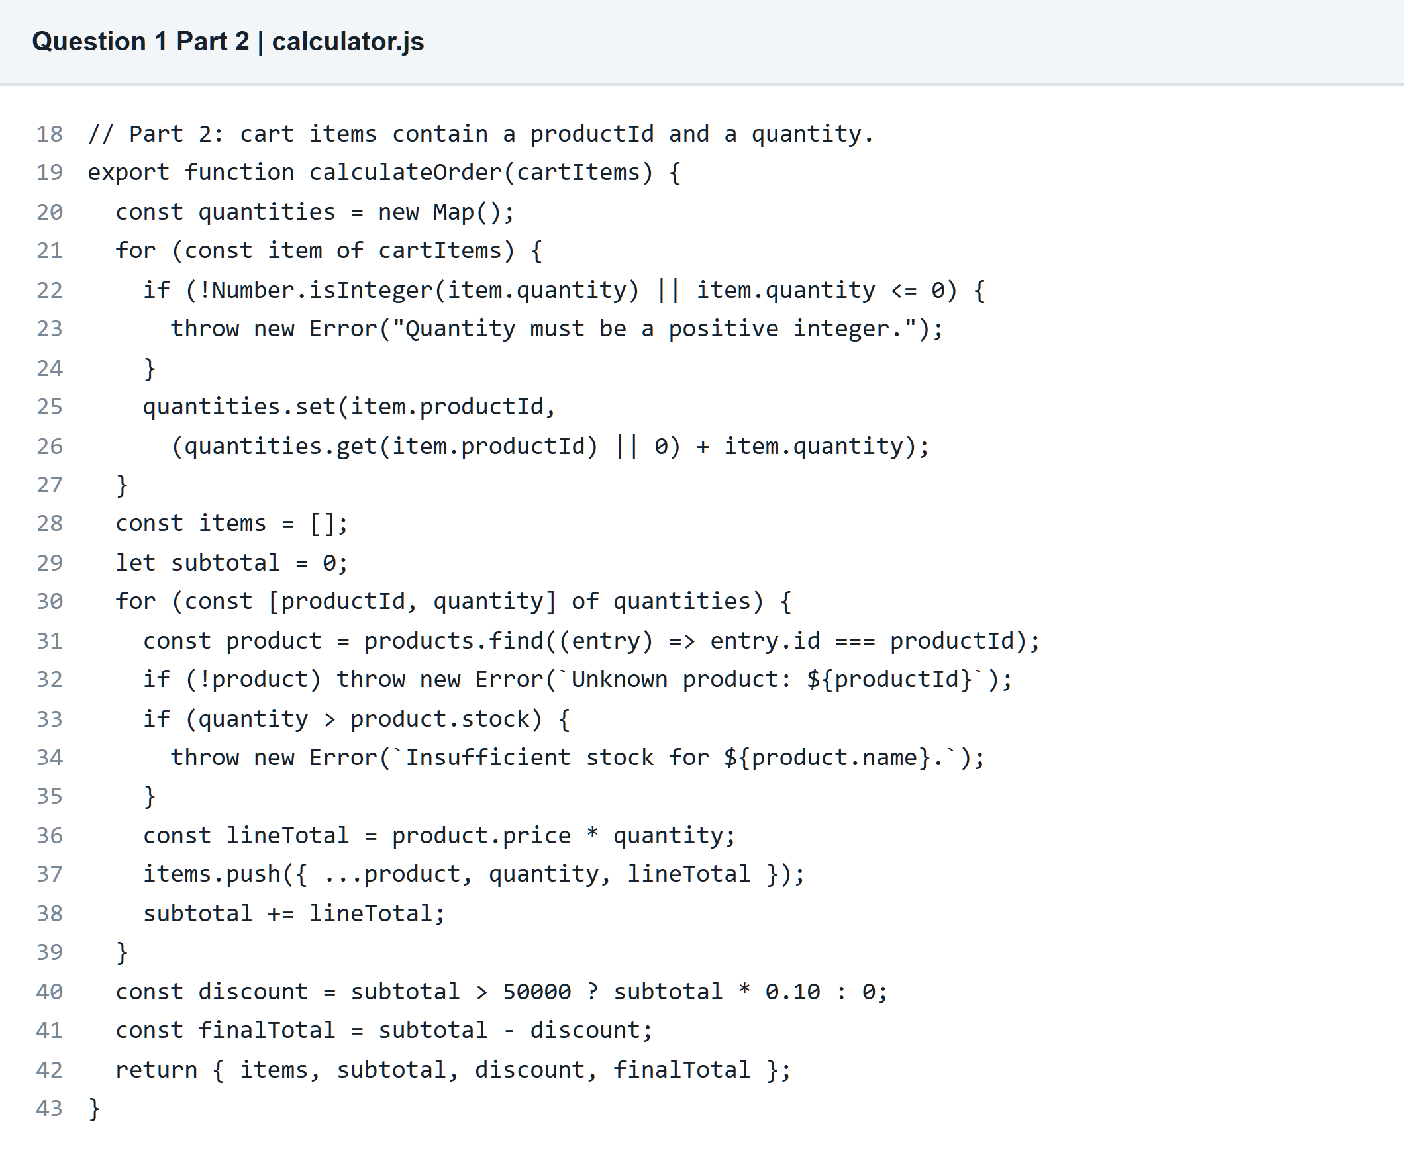

Question 1 Product Order Calculator
Part 3 Display an invoice
JavaScript code and sample cart
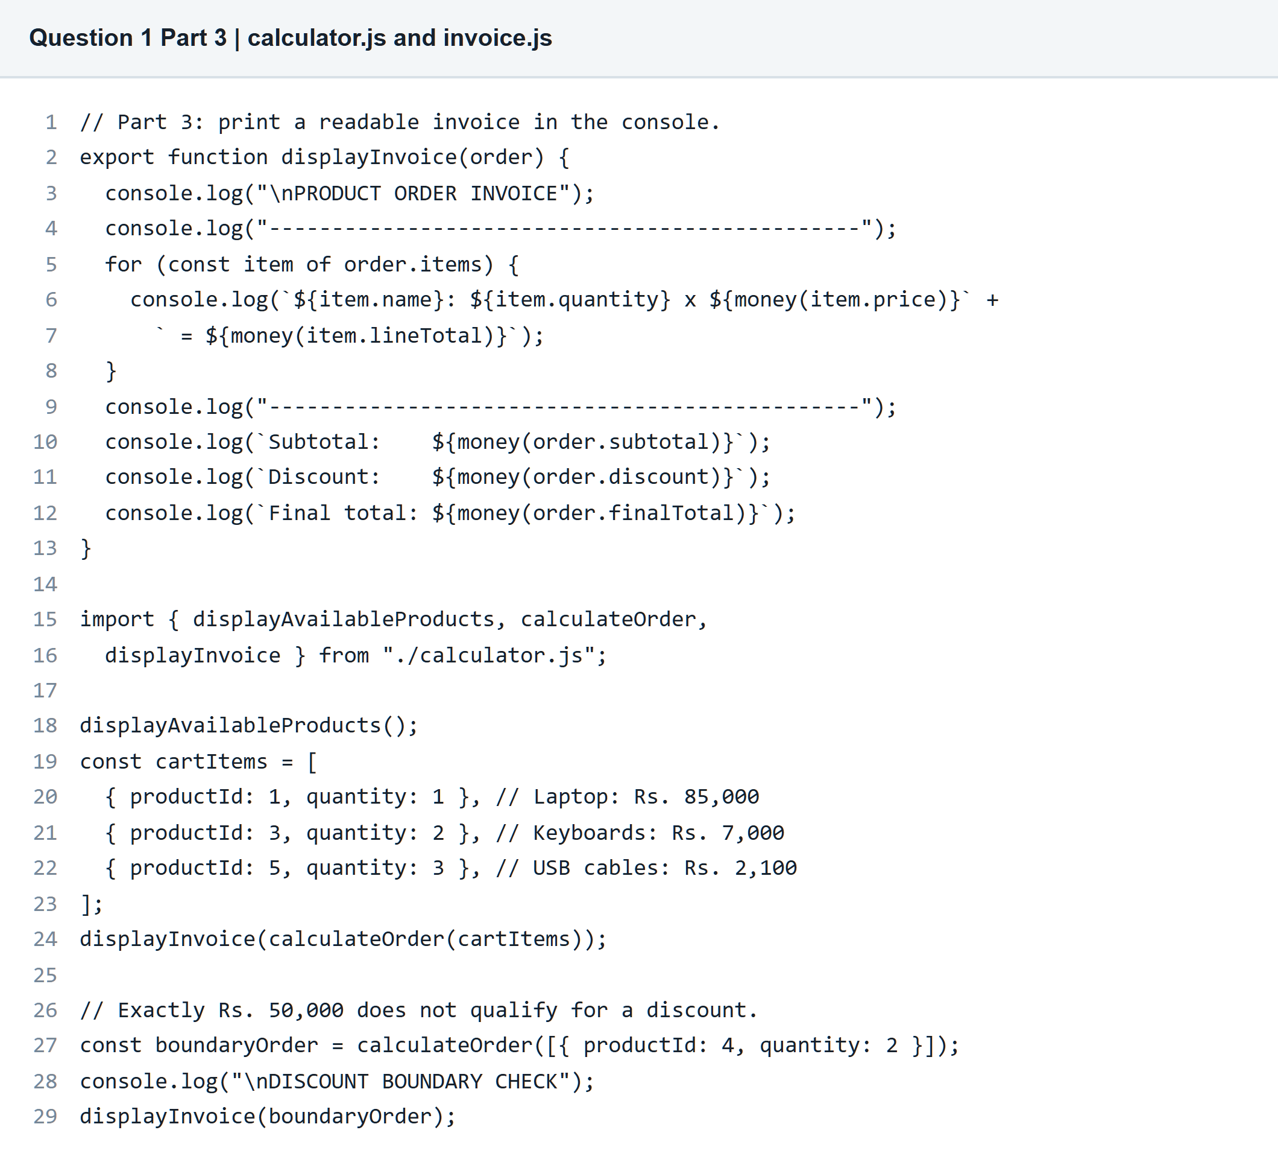

Question 1 Product Order Calculator
Parts 1 to 3 Program output
Available products and two invoices
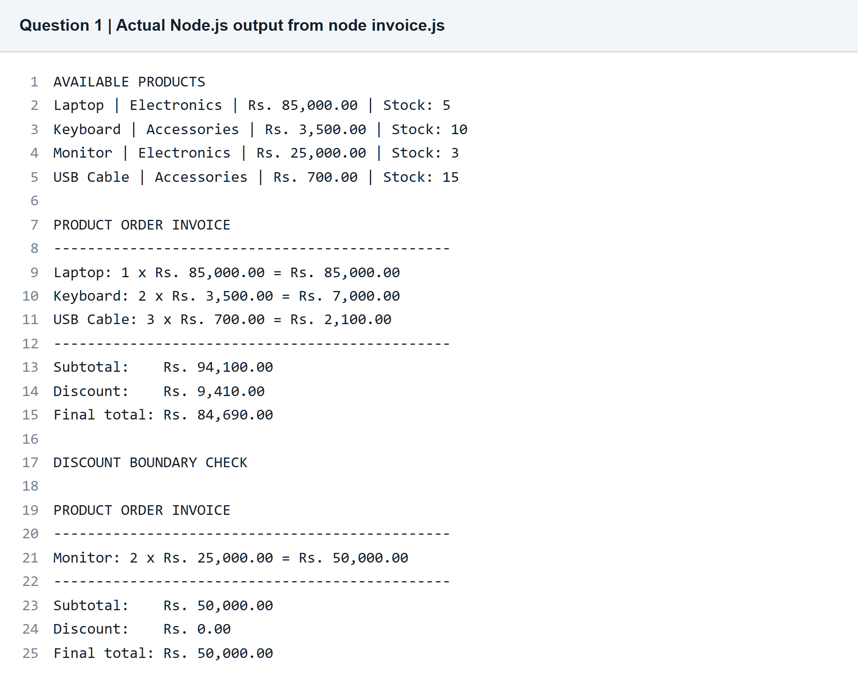

Question 2 React Product Catalog
Part 1 Create the Vite project
Project configuration and React entry point
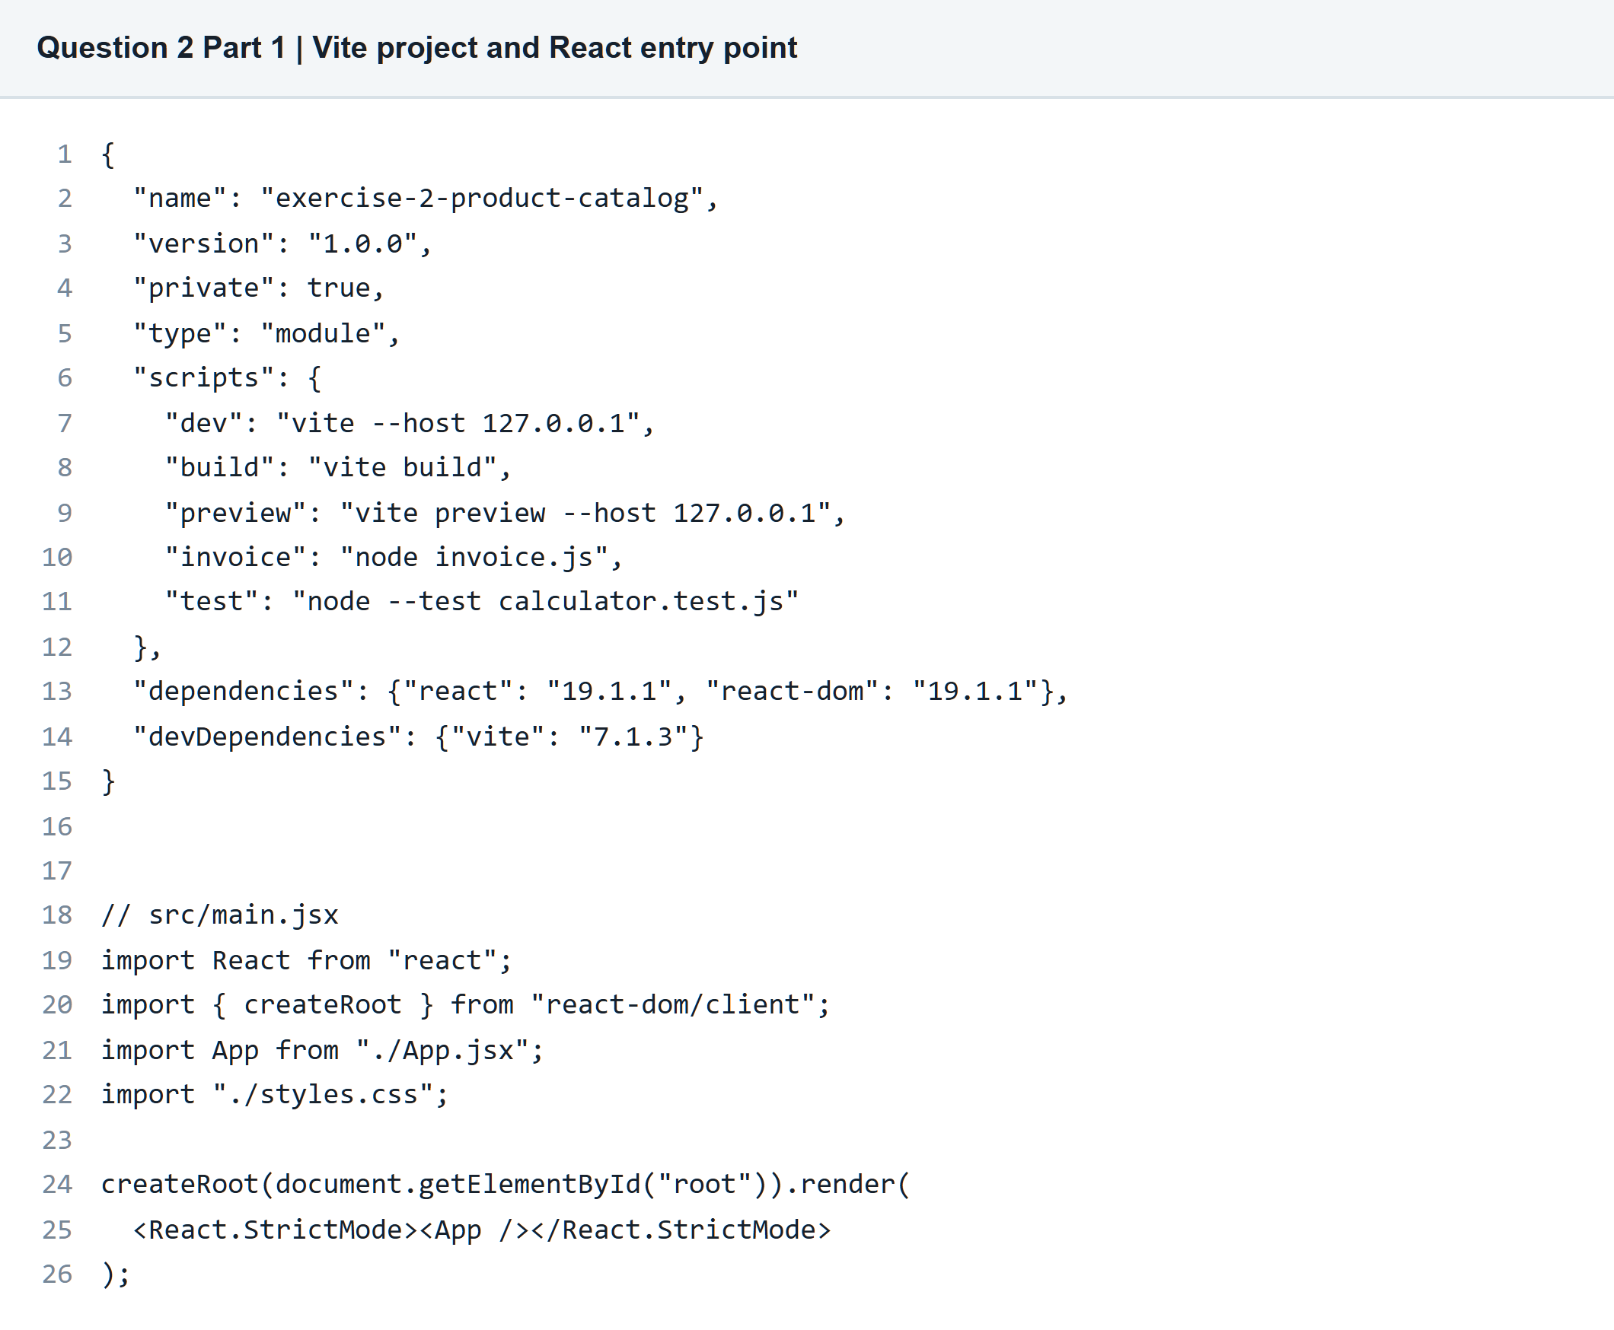

Question 2 React Product Catalog
Part 1 Create ProductCard
Component code with props and stock status
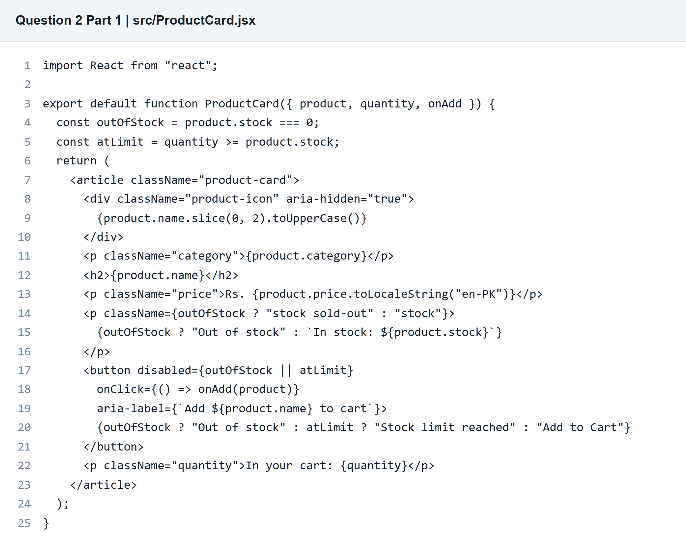

Question 2 React Product Catalog
Part 2 Render the product array
Main page rendering with map
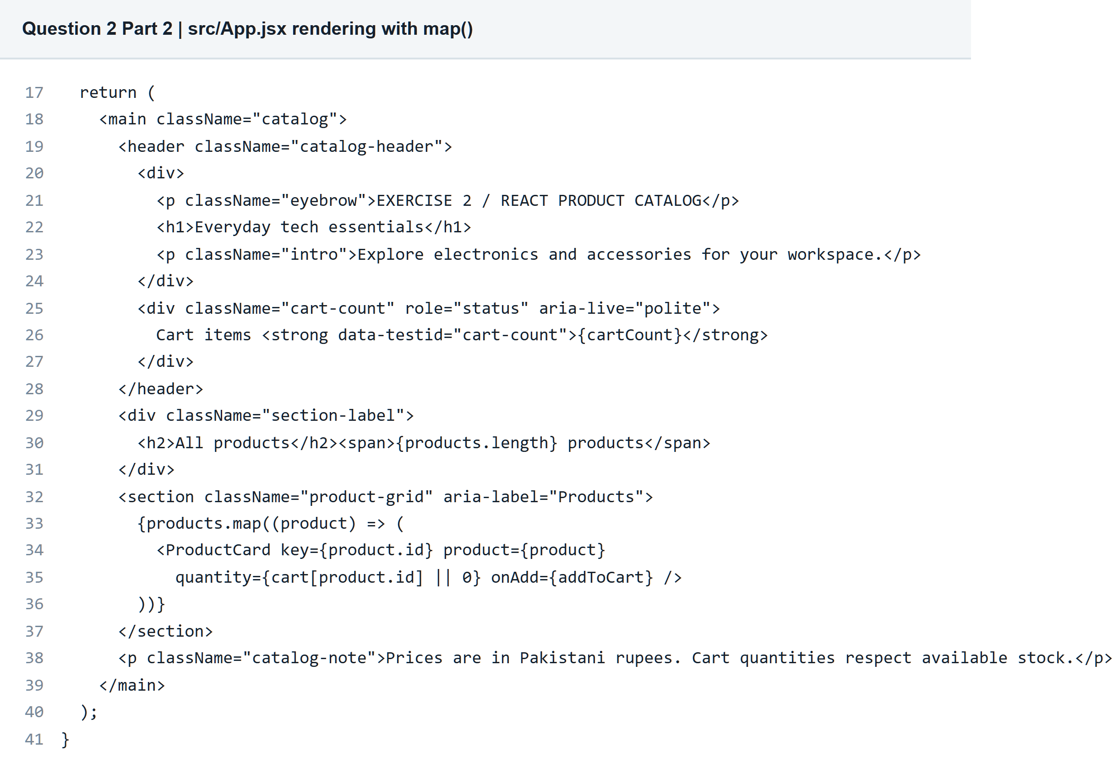

Question 2 React Product Catalog
Part 2 Style the catalog
CSS grid and page layout
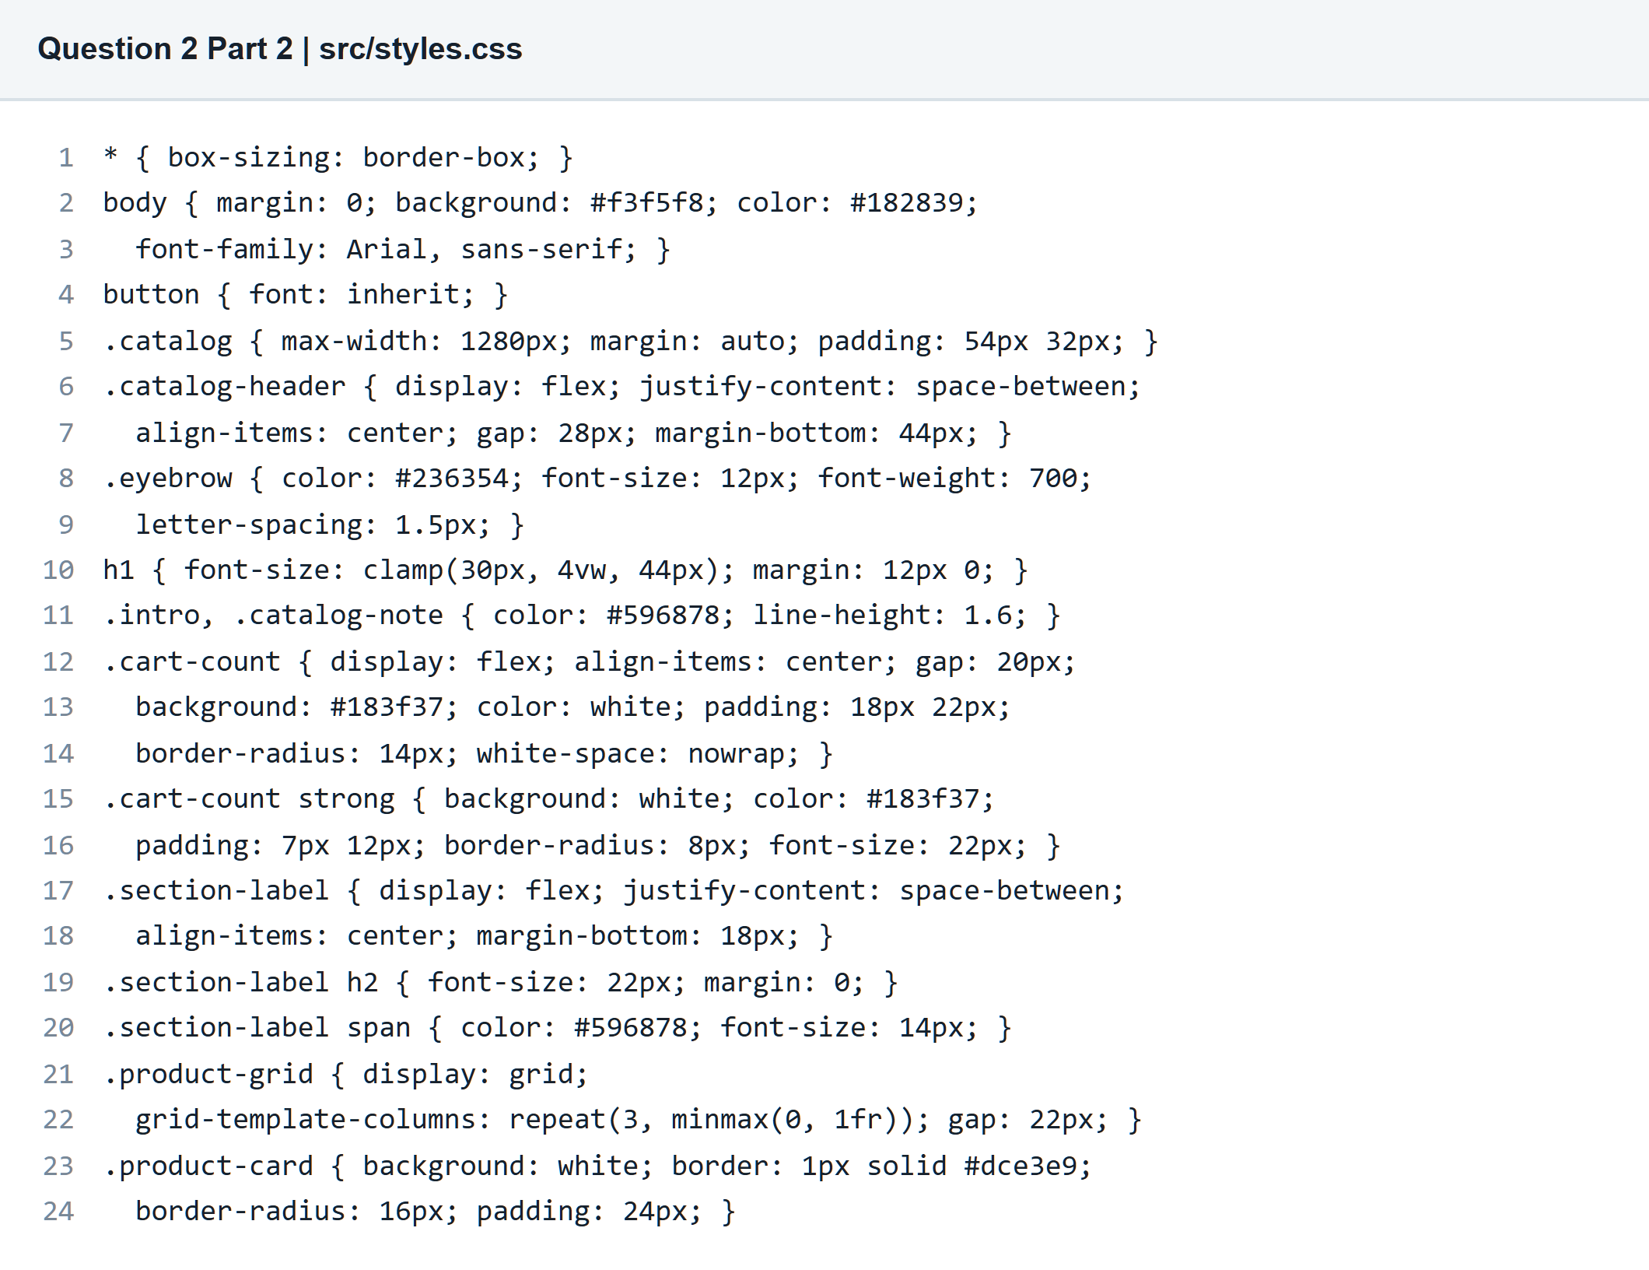

Question 2 React Product Catalog
Part 2 Add responsive styling
Card styling and responsive breakpoints
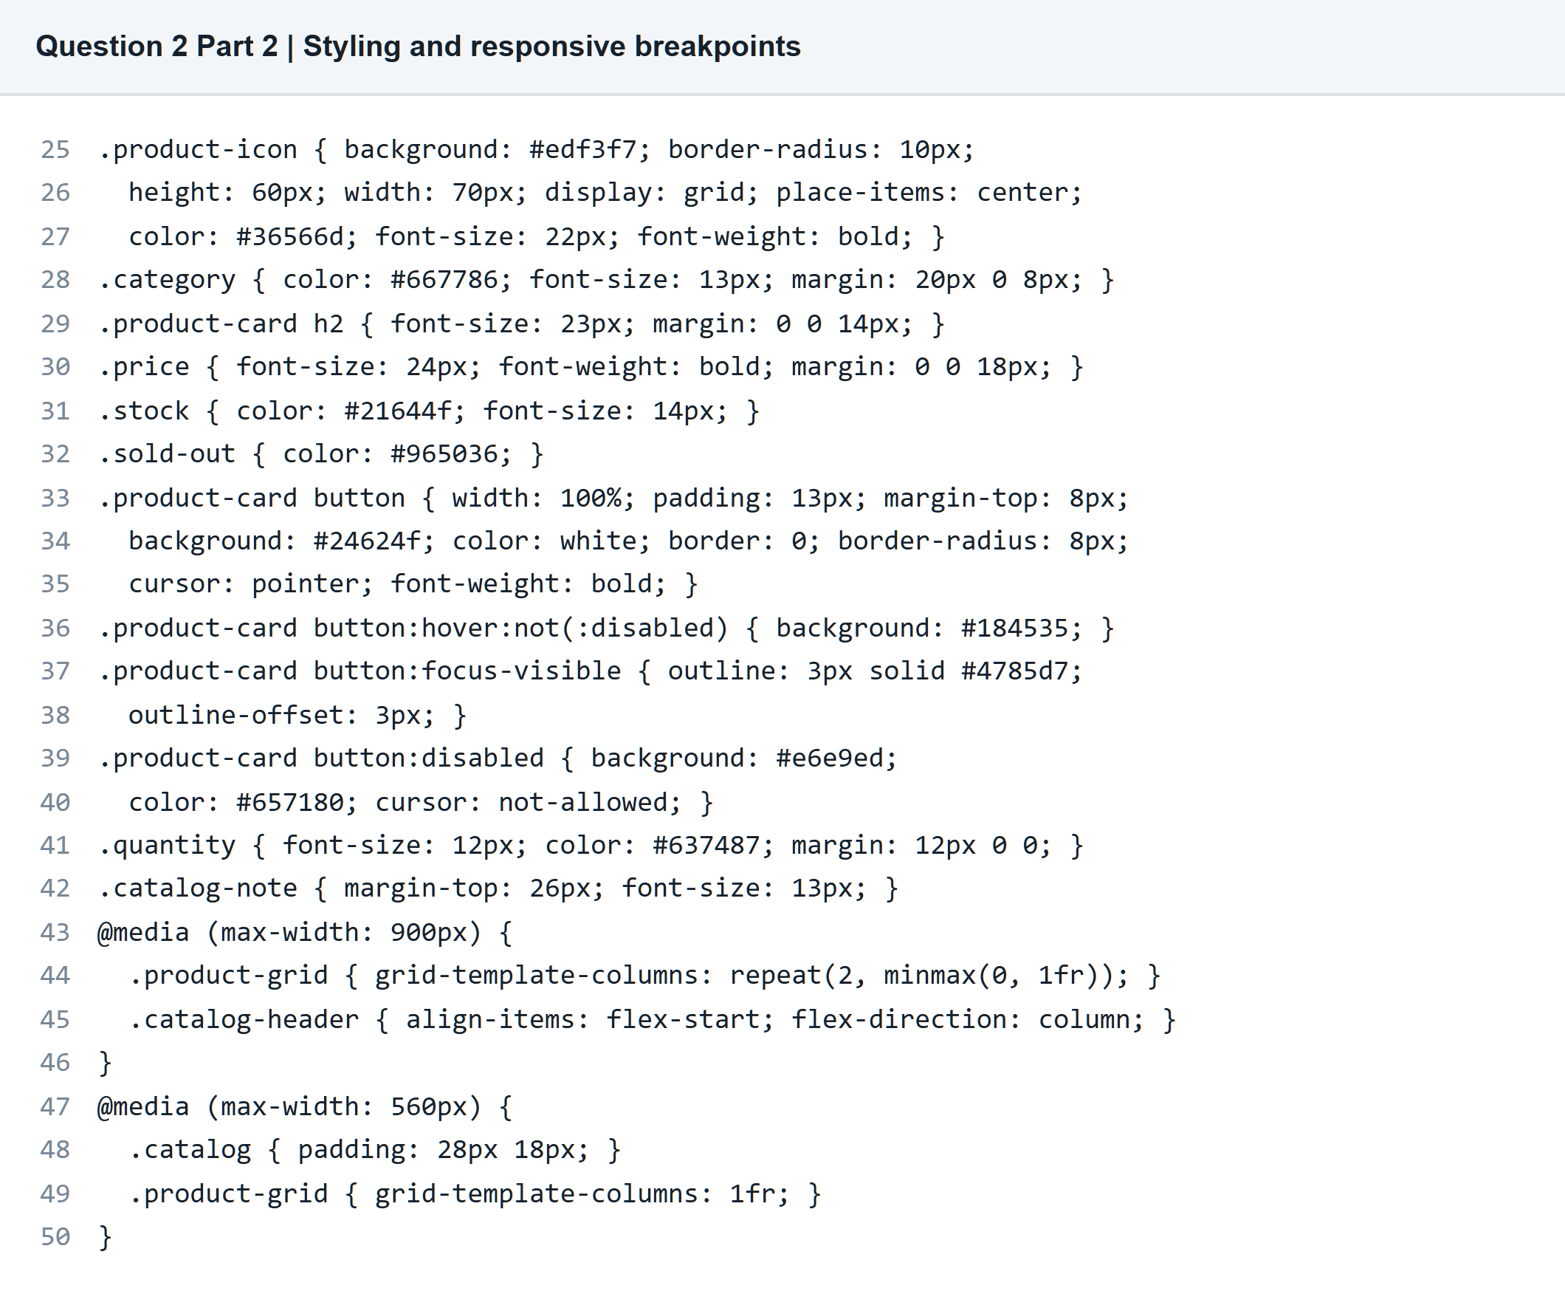

Question 2 React Product Catalog
Part 2 Desktop browser output
Five cards and disabled out of stock product
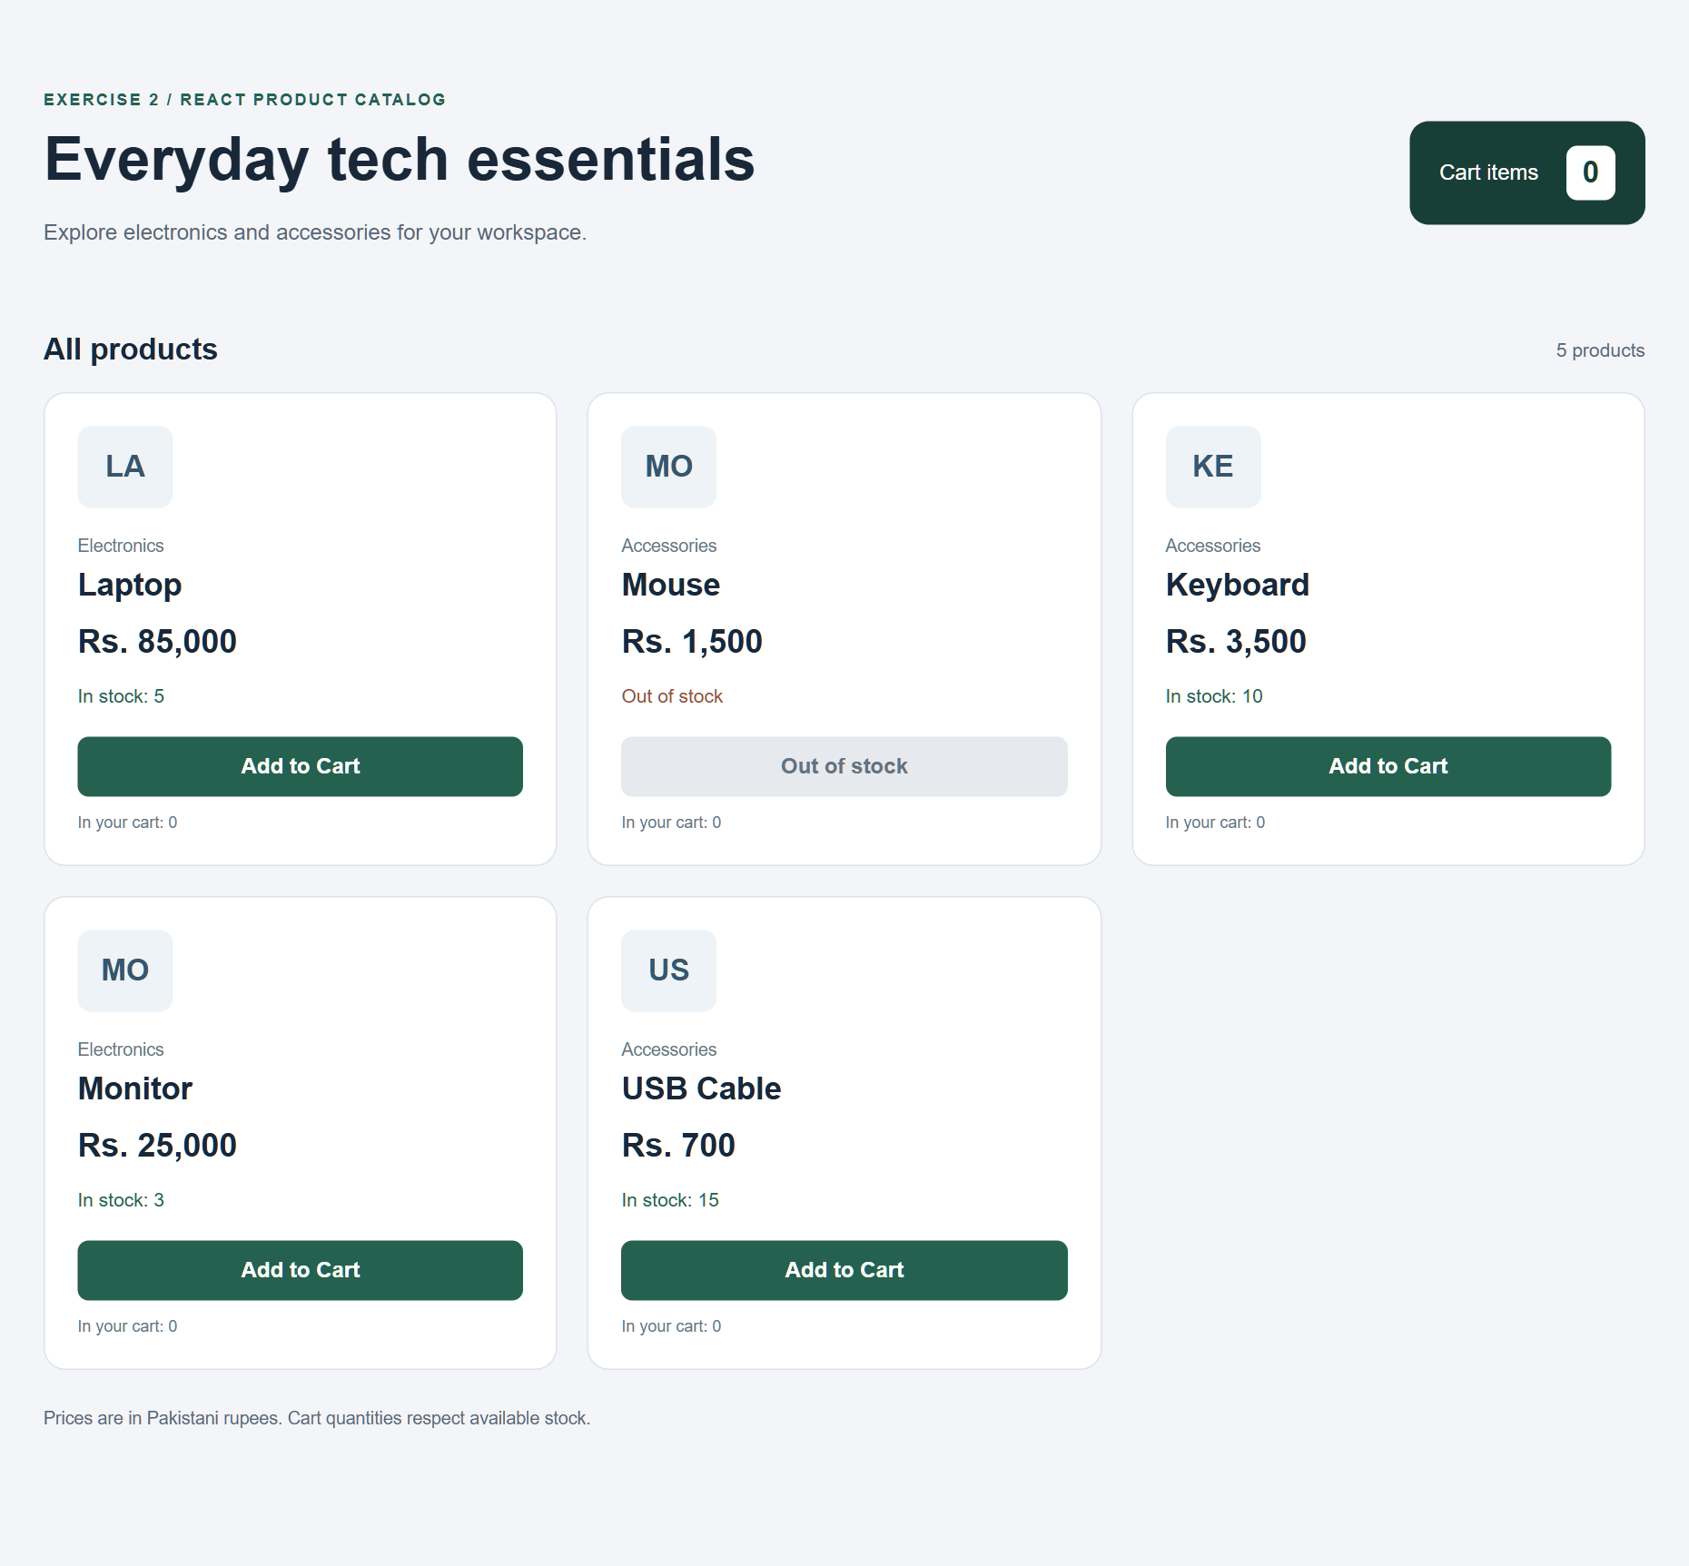

Question 2 React Product Catalog
Part 3 Track the cart with state
React state and Add to Cart event handler
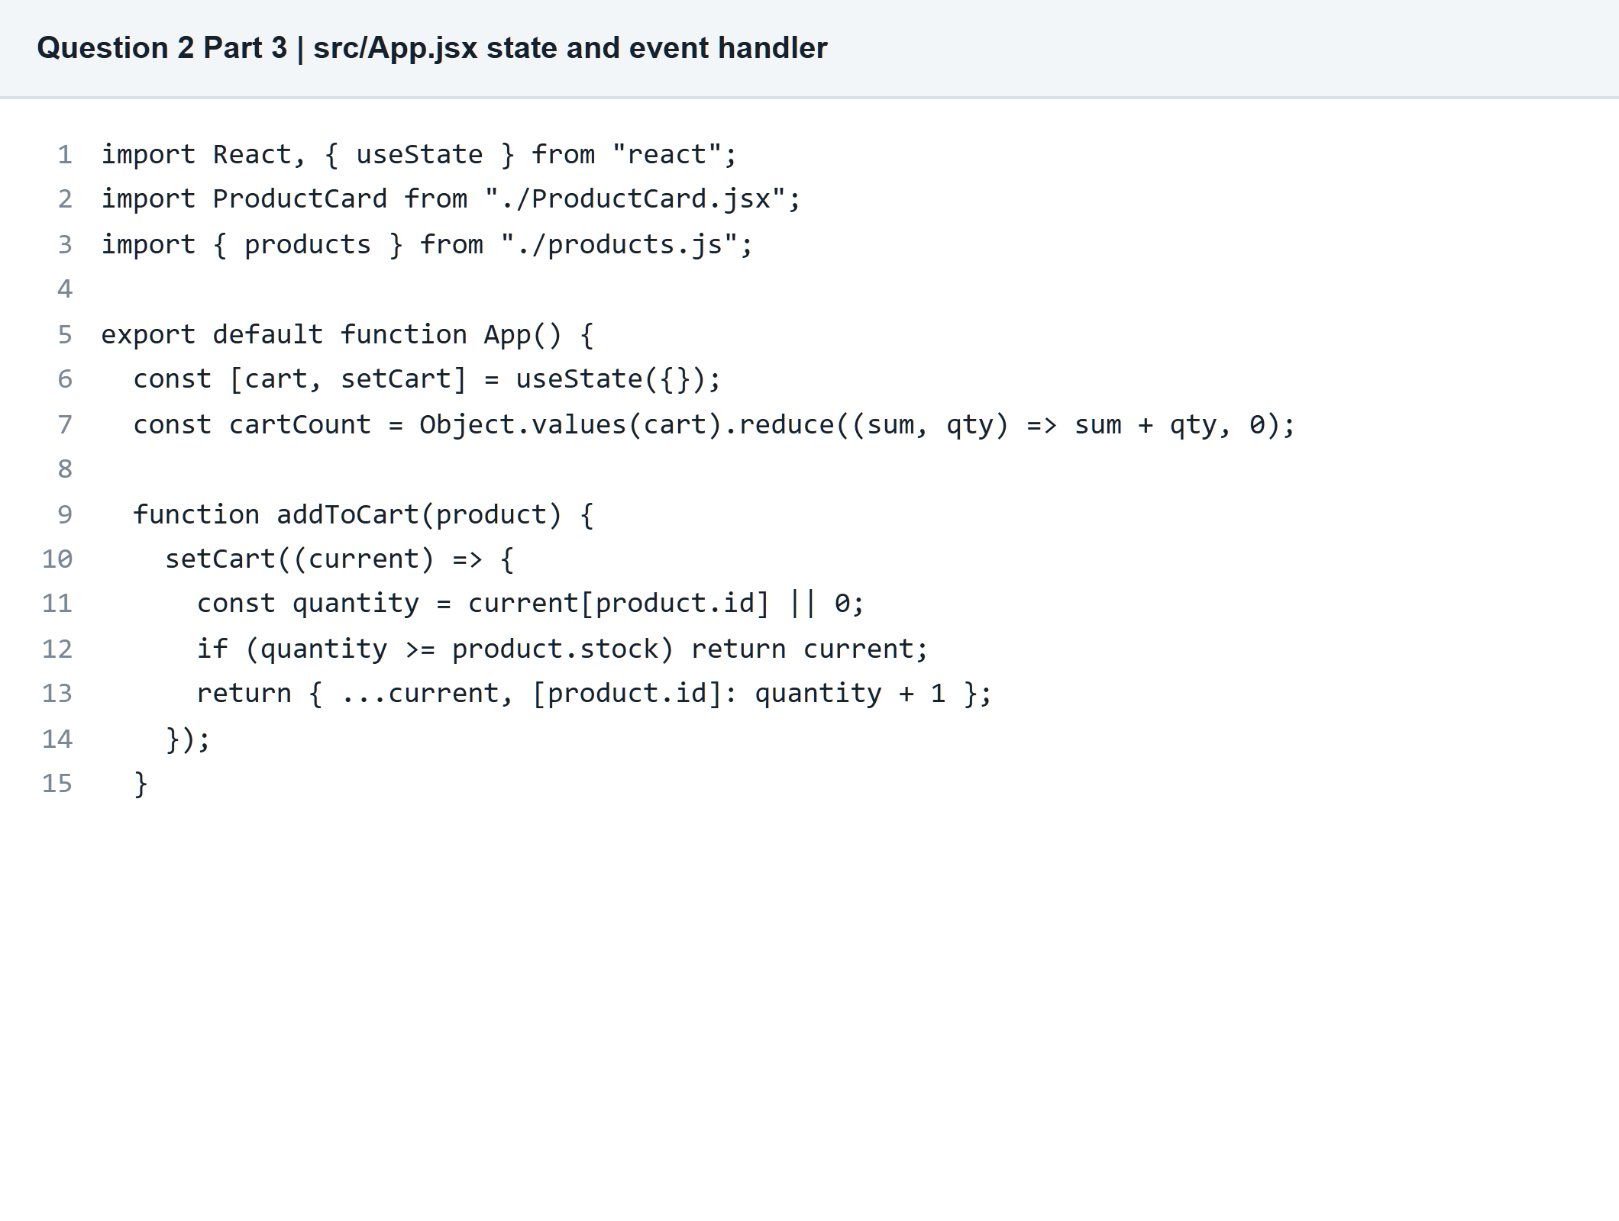

Question 2 React Product Catalog
Part 3 Updated browser output
Cart count is 3 after one laptop and two keyboards
